***Chemistry***

**9:** Gases

**9.6:** Non-Ideal Gas Behavior

99. Graphs showing the behavior of several different gases follow. Which of these gases exhibit behavior significantly different from that expected for ideal gases?

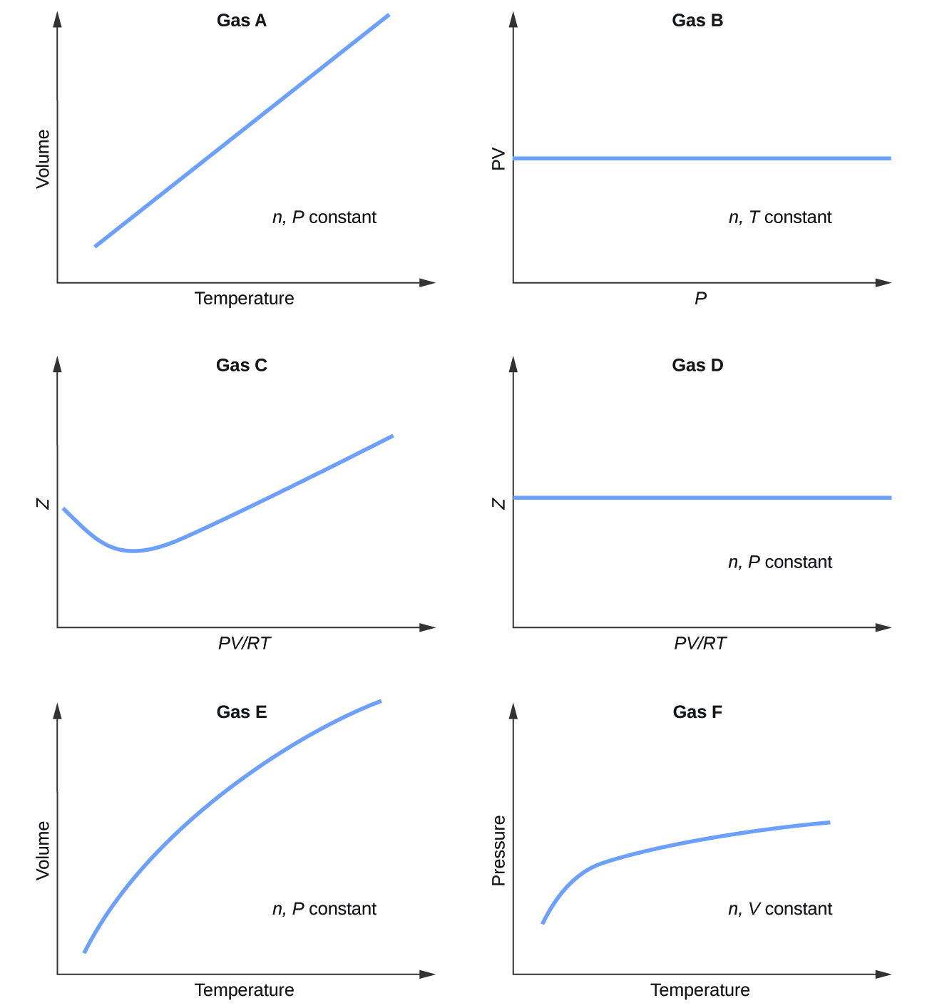

Solution

Gas A: volume increases linearly as temperature increases with moles and pressure held constant, as expected by the ideal gas law *V* = (***nR***/***P***)*T*; Gas B: *PV* stays constant as pressure increases with moles and temperature held constant, as expected by the ideal gas law *PV* = ***nRT***; Gas C: compressibility factor (Z) varies as *PV*/*RT* increases, as expected of a real gas; Gas D: compressibility factor (Z) stays constant as *PV*/*RT* increases with moles and pressure held constant, as expected of an ideal gas; Gas E: as temperature increases, volume increases, but not linearly with moles and pressure held constant, as would **not** be expected by the ideal gas law *V* = (***nR*/*P***)*T*, as seen in Gas A; Gas F: as temperature increases, pressure increases with moles and volume held constant, but not linearly, as would **not** be expected by the ideal gas law *P* = (***nR*/*V***)*T*, as seen in Gas A; Gases C, E, and F exhibit behavior significantly different from that expected for an ideal gas.

101. Under which of the following sets of conditions does a real gas behave most like an ideal gas, and for which conditions is a real gas expected to deviate from ideal behavior? Explain.

(a) high pressure, small volume

(b) high temperature, low pressure

(c) low temperature, high pressure

Solution

The gas behavior most like an ideal gas will occur under the conditions in (b). Molecules have high speeds and move through greater distances between collisions; they also have shorter contact times and interactions are less likely. Deviations occur with the conditions described in (a) and (c). Under conditions of (a), some gases may liquefy. Under conditions of (c), most gases will liquefy.

103. For which of the following gases should the correction for the molecular volume be largest:

CO, CO2, H2, He, NH3, SF6?

Solution

We would expect the molecule with the largest volume to need the largest correction. SF6 would need the largest correction.

105. Answer the following questions:

(a) If XX behaved as an ideal gas, what would its graph of Z vs. P look like?

(b) For most of this chapter, we performed calculations treating gases as ideal. Was this justified?

(c) What is the effect of the volume of gas molecules on Z? Under what conditions is this effect small? When is it large? Explain using an appropriate diagram.

(d) What is the effect of intermolecular attractions on the value of Z? Under what conditions is this effect small? When is it large? Explain using an appropriate diagram.

(e) In general, under what temperature conditions would you expect Z to have the largest deviations from the Z for an ideal gas?

Solution

Answer: (a) A straight horizontal line at 1.0 (see Figure 9.35) for the line representing an ideal gas; (b) when real gases are at low pressures and high temperatures they behave close enough to ideal gases that they are approximated as such, however, in some cases, we see that at a high pressure and temperature, the ideal gas approximation breaks down and is significantly different from the pressure calculated by the van der Waals equation. (c) the greater the compressibility, the more the volume matters. At low pressures, the correction factor for intermolecular attractions is more significant, and the effect of the volume of the gas molecules on Z would be a small lowering compressibility. At higher pressures, the effect of the volume of the gas molecules themselves on Z would increase compressibility (see Figure 9.35) (d) Once again, at low pressures, the effect of intermolecular attractions on Z would be more important than the correction factor for the volume of the gas molecules themselves, though perhaps still small. At higher pressures and low temperatures, the effect of intermolecular attractions would be larger. See Figure 9.35. (e) low temperatures

This resource file is copyright 2015, Rice University. All Rights Reserved.